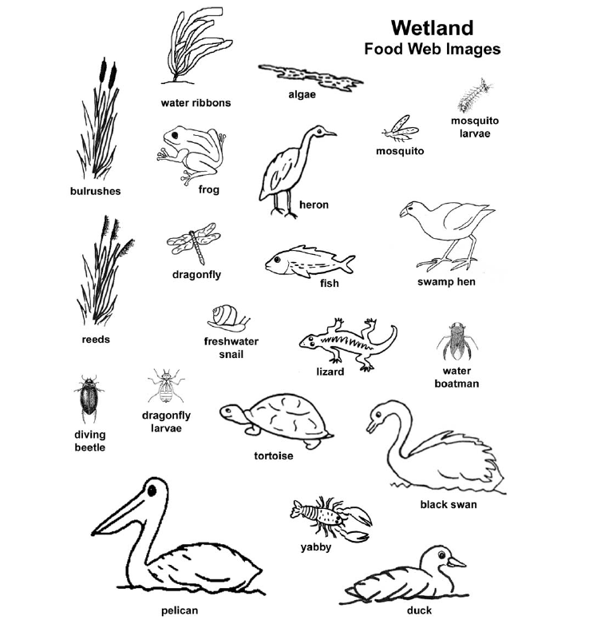

Constructing a food web

The Torrens River starts in the Adelaide hills as several small creeks which join to form one larger creek. As it winds its way down the hills to the city, more and more water is added. It generally only flows in winter when the rainfall is sufficient, and dries up into small waterholes during the summer. A weir is used to hold water permanently in the city. It is surprising how many organisms rely on the river for their existence.

Algae can be observed growing in the water, as well as water ribbons (Triglochin procerum). On the water edge, fluffy topped reeds such as the common reed (Phragmites australis) and the bulrush (Typhus sp) grow. Water boatman are observed swimming in the water. They are eating the algae and reeds. Mosquitoes both larvae and adults also eat the algae plus an adult female mosquito will need an extra source of protein provided by the blood of an animal before she is able to produce eggs. The fresh water snail eats both the algae and water ribbons. A long necked tortoise pokes its nostrils above the water. The tortoise eats the algae too, as well as feeding on snails, boatman and yabbies. The water boatman provides food for many species including fish, frogs, diving beetles and dragonfly larvae. The yabbies are scavengers, feeding on rotting plant and animal matter, while bacteria also help break down this dead material by digesting it and recycling nutrients in the food web. The mosquito larvae are considered a delicacy for frogs (such as the common froglet) and several varieties of fish (such as the big-headed gudgeon or the congolli).

Birds are in abundance along the waterway. Pacific black ducks are feeding on fish, dragonfly larvae and diving beetles, while the occasional visiting pelican feeds on fish, frogs and dragonfly larvae. Black swans make a beautiful sight, bending their elegant necks to forage under the water grazing on the water ribbons, snails and an occasional fish. The white-faced heron makes a meal of the fish and frogs. The purple swamp hen runs quickly from the bulrushes where it feeds on the tender growth of the bulrushes and also makes its nest. On the bank, a blue-tongue lizard is sunning itself in a warm rock. It snaps at the dragonflies, mosquitoes and diving beetles and beware the unwary frog; the lizard will sometimes eat them too.

Divide the organisms into the following categories (if they occur in more than one category then add in both categories):

Producers | Ist Order Consumer | 2nd Order Consumer (and higher)
Decomposers | Scavengers

Cut out the images and position on a piece of poster paper. Only when you are happy with your placement, glue the animals in place and complete the arrows to show the flow of energy.

Remember:
- The arrow shows the direction of energy flow (i.e. the arrows points towards the animal that is doing the eating)
- The producers should be on the bottom of the page, top predators on the top of the page
- Try to keep organisms within their trophic level (although this is difficult at times as one organism can occupy more than one trophic level).
Attempt to display the relationships as clearly as possible by minimising the number of times arrows cross

